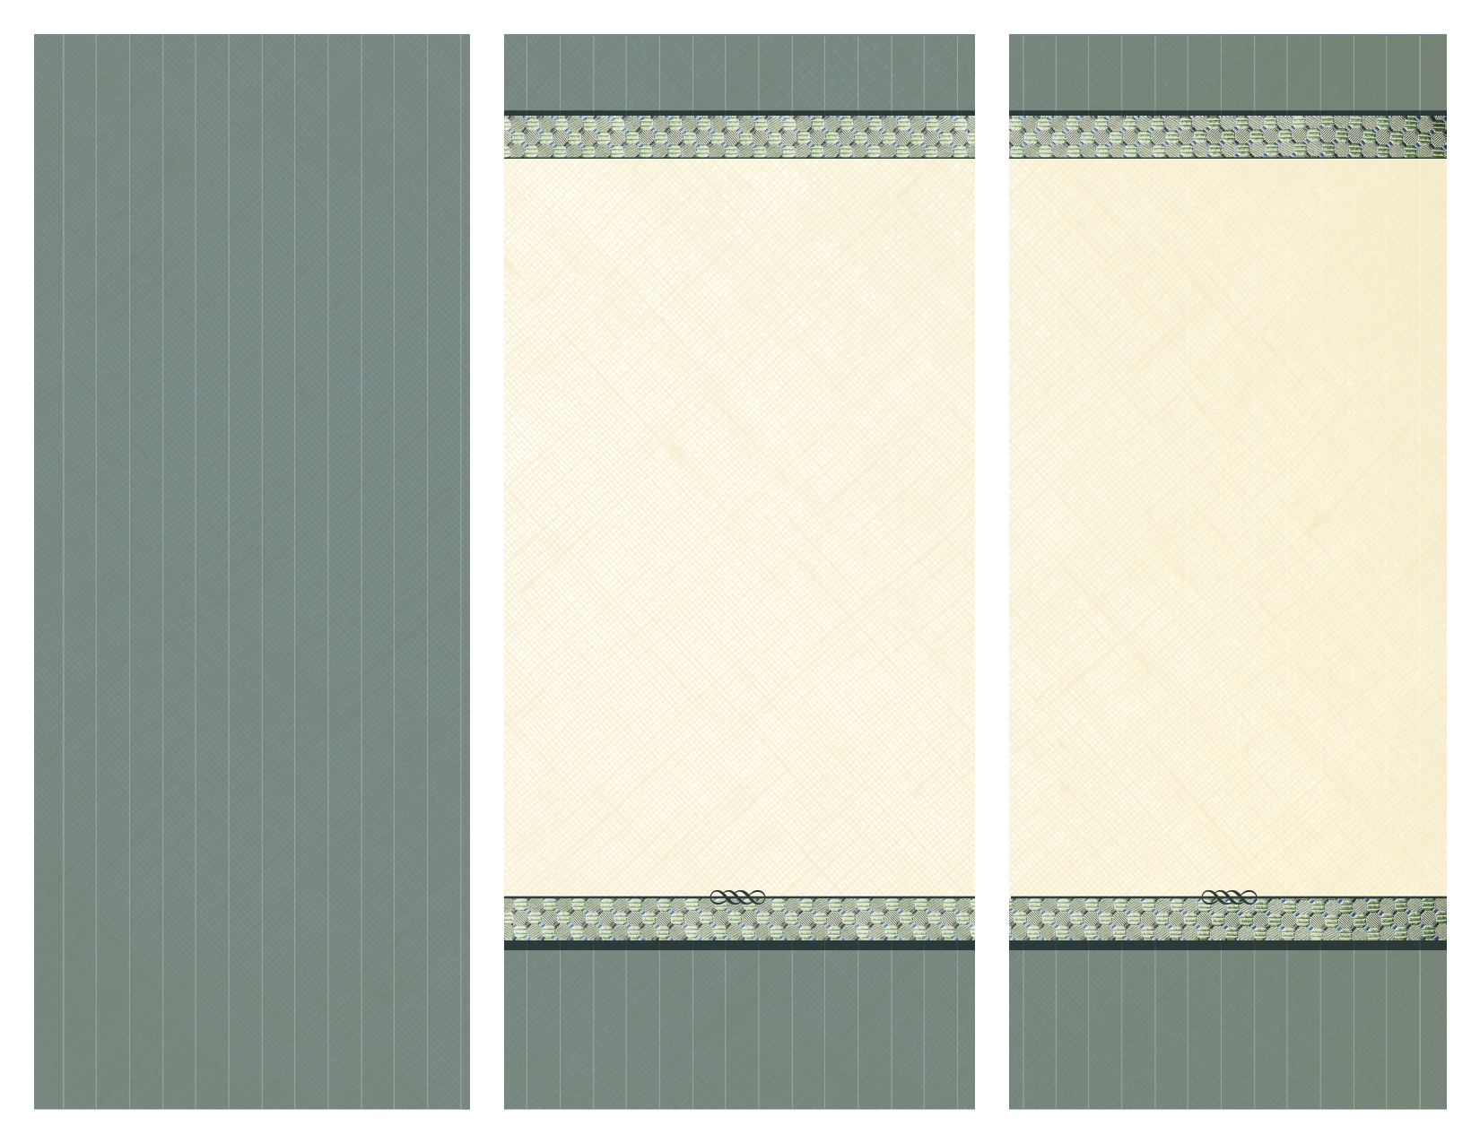C:\Documents and Settings\cvantine\Local Settings\Temporary Internet Files\Content.IE5\399LLDKR\MC900027548[1].wmf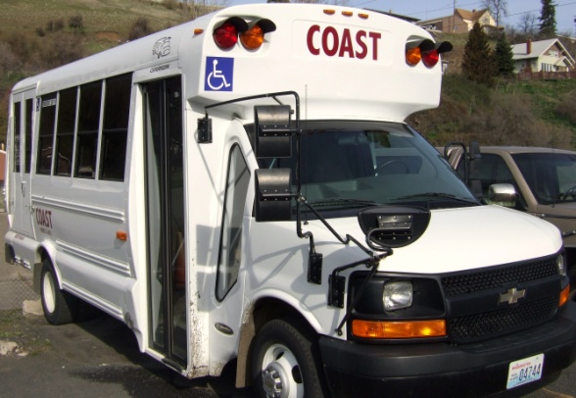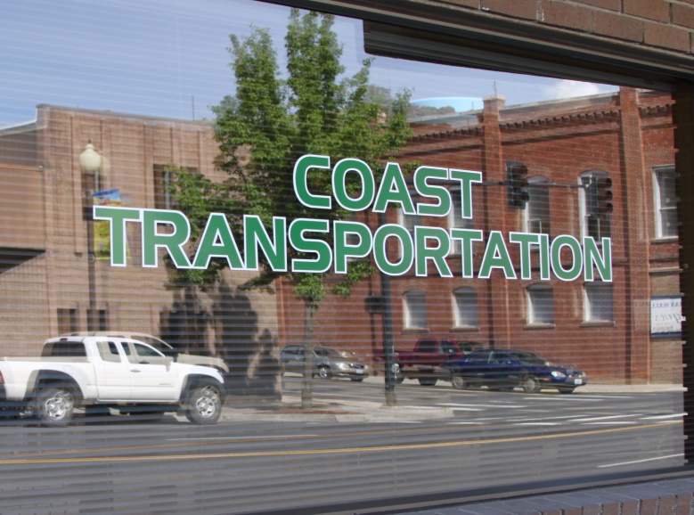

**The Public Transportation program, COAST, will maintain services and options for mobility by providing safe, affordable, accessible and coordinated transportation services.**

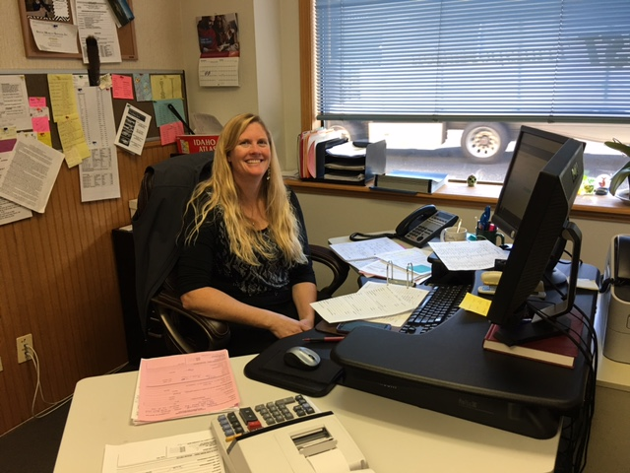

The Council on Aging & Human Services operates its programs without regard to race, color, and national origin. To receive additional information on its discrimination obligations, including its complaint procedures, please contact

Christine O’Keefe at 509-397-2935 or [cokeefecoast@gmail.com](mailto:cokeefecoast@gmail.com).

COAST Transportation is committed to providing safe, reliable, and accessible transportation options for the geographic areas served. COAST Transportation has established a Customer Complaint Policy and customers wishing to file a complaint and/or obtain a copy of the Customer Complaint Policy may contact COAST Transportation at (509) 397-2935, or in person at COAST Transportation’s administration office located at 210 S. Main St., Colfax, WA.

Retribution by COAST, CoA&HS, or any contracted provider towards anyone filing a complaint is prohibited.

.

**Complaint Policy**

**S. 210 Main St./Box 107**

**Colfax, WA 99111**

**509-397-2935 office • 509-397-9229 fax**

**1-800-873-9996 WA toll free**

**1-800-967-2899 ID toll free**

**www.coacolfax.org**

Transportation Division of the

Council on Aging & Human Services

coast transportation

**210 South Main Street**

**Colfax, WA 99111**

**Complete ADA, Comment, and Complaint Policies and Procedures are available on our website:**

**Coacolfax.org**

**Written copies will also be sent to you, upon request, or may be picked up at our administrative offices in Colfax.**

COAST Transportation

**509-397-2935 office • 509-397-9229 fax**

**1-800-873-9996 WA toll free**

**1-800-967-2899 ID toll free**

**www.coacolfax.org**

The Americans with Disabilities Act (ADA) was signed into law on July 26, 1990. The ADA is civil rights legislation which requires that persons with disabilities receive transportation services equal to those available on the fixed route service.

It is the policy of COAST Transportation that, when viewed in their entirety, services, programs, facilities, and communications provided by COAST Transportation, directly or by a contracted service provider, are readily accessible and usable to individuals with disabilities to the maximum extent possible.

1. **Fares**

By suggested donation only. There are no fares.

1. **Holiday Closures**

COAST Transportation is closed on the following nationally recognized holidays: New Year’s Day, Martin Luther King Day, Memorial Day, Independence Day, Labor Day, Thanksgiving Day, the day after Thanksgiving and Christmas Day. In rare or unique situations, rides may be scheduled for holiday trips.

1. **Approved Equipment**

In order to accommodate your wheelchair or power scooter on a COAST Transportation vehicle it must meet identified standards.

**4. Personal Care Attendant**

A Personal Care Attendant (PCA) may ride with you at no charge. A PCA is someone who travels with, and helps, a rider who is not able to travel alone. You must provide your own PCA if you need one. Please let us know when scheduling a ride whether or not you will be using a PCA. This information will guarantee a place for him or her to ride with you.

**5. Service Animals**

A service animal is any guide dog, signal dog, or other animal individually trained to work or perform tasks for an individual with a disability.

**6. Loss of Services**

A rider’s privileges may be suspended for any of the following infractions on any COAST Transportation property, including vehicles or offices: Smoking or carrying a lit pipe, cigar, or cigarette (unless in a designated smoking area)…Discarding or dumping litter in places other than the recognized receptacles…Consuming alcoholic beverages or in possession of alcoholic beverages… Loud, raucous, unruly, harmful, or harassing behavior…Engaging in other conduct that is inconsistent with the intended purpose of the transportation office or vehicle.

**Public Transportation for All**